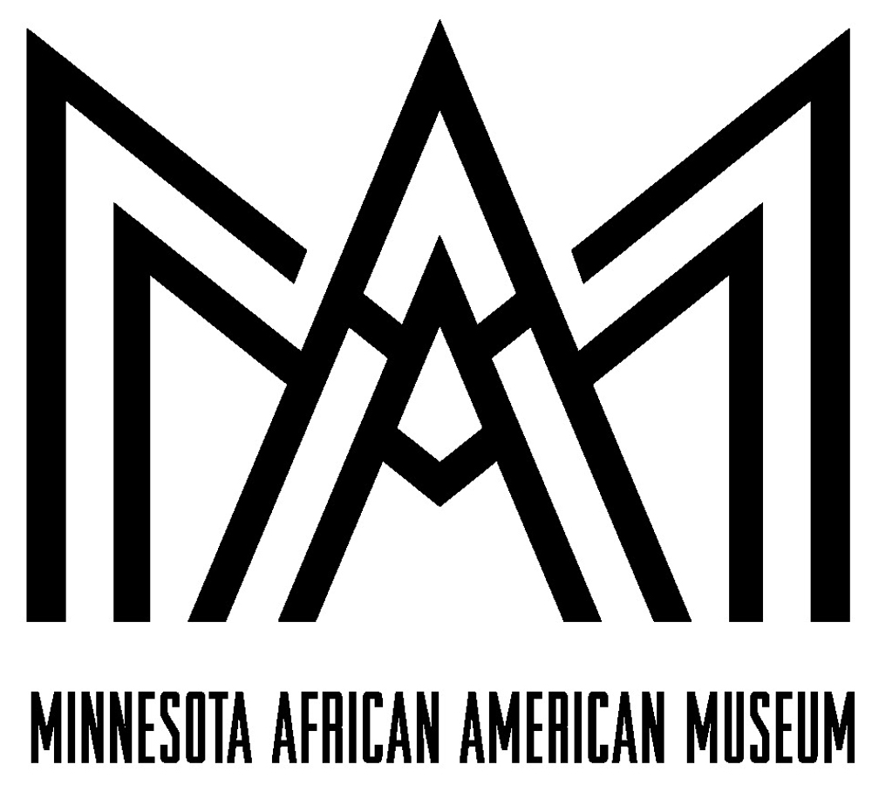

The Minnesota African American Museum (MAAM) is an educational, cultural and archival museum dedicated to researching, presenting, acquiring and preserving the history of African Americans in Minnesota and beyond. MAAM's goal is to inform, and enlighten all, to the many contributions made by African Americans impacting Minnesota and beyond

Join the MAAM Experience

Volunteer Application

Contact Information

Name (Last, First)

Street Address

City ST ZIP Code

Day Phone

Cell Phone

E-Mail Address

Availability

Please indicate the Days and provide the Times you are available to volunteer.

Volunteers provide a regular commitment of time, ranging from one half-day bi-weekly to several days per week. MAAM is open to the public six days a week during the fall and winter months and seven days a week over the summer, and volunteers assist at all times. The minimum commitment of three months is required in most volunteer positions; however because of the extended training necessary for certain positions, longer commitments are sometimes required. All the “behind the scenes” volunteer positions, including the research assistants, are only available Monday-Friday during normal business hours.
_____ Monday | _____ Thursday | _____ Sunday
_____ Tuesday | _____ Friday
_____ Wednesday | _____ Saturday

Background Information

Do you speak a language(s) in addition to English? If so, which language?

Highest level of education completed?

Do you have experience working with children?

If so, please explain below.

Will you allow MAAM to perform a background check?

Please tell us any characteristics, skills and experiences that you think will assist you as a MAAM volunteer?

Emergency Contact

Name

Cell Number

E-Mail Address

Area(s) of Interest (please check all that apply)

Senior Docent______

Research_________ Office_____________

Youth Docent________ Curatorial__________ Facilities/Grounds________

Children's Village_______ Reception/Greeters________ Technology____________

Education________ Oral History______ Archiving Collections_________

Gift Shop____________ Special Events & Programing__________ Social Media_________

What made you decide to volunteer at MAAM---Please ✔ check all applicable response

Friend/coworker_____ MAAM website______ Schoool________

Media_______ MAAM newsletter_______

Other____________________________

Past Volunteer Experience

Please describe any previous volunteer experience you have had, including job duties, hours per week, projects.

Personal References

Please provide two references we may contact:

Reference Name

Reference Telephone Number

Reference Name

Reference Telephone Number

Agreement and Signature

I affirm that to the best of my knowledge, the above stated information is factually true and complete. If, at a later date, MAAM discovers any portion of this application to be untrue, incorrect, or false, it may result in my immediate dismissal as a volunteer.

Name (printed)

Signature

Date

Thank you for saying Yes MAAM!

Please return this application to:

The Minnesota African American Museum

1700 Third Avenue South

Minneapolis, Mn. 55404

Info@maamcc.org

**Administration only** Do Not Write/Type in this section

Date Received:
Assigned: YES NO | Project:
Supervisor: | Start Date:
End Date: | Reason for leaving:

